Press Release

Cost-effective manufacturing of large-volume components now possible with combined SLM and casting method

In the past, selective laser melting (SLM) technology has been cost effective only for manufacturing components with relatively small volumes. In an innovative breakthrough that combines SLM with casting, now the Fraunhofer Institute for Laser Technology ILT has developed a cost-effective method for manufacturing solid, large-volume components using SLM. For the first time at EuroMold 2014, experts will be presenting tool inserts with conformal cooling channels that were made using the combined method.
Injection molding is used to make the majority of plastic components. With additive manufacturing techniques such as SLM, it is possible to integrate complex conformal cooling channels into the tool inserts required for injection molding. These channels allow the tool mold to be heated up during the injection process, and the melt to cool down quickly and evenly – resulting in rapid, distortion-free manufacturing. However, the manufacture of large-volume tool inserts using SLM is very cost-intensive, because the main production costs are volume-dependent.

To tackle this problem, scientists from Fraunhofer ILT have teamed up with the Foundry Institute at RWTH Aachen University and partners from industry in a bid to combine SLM and casting methods. In the “GenCast” project, which is funded by the German Federal Ministry for Economic Affairs and Energy as part of the Central Innovation Program SME (or “ZIM” in German), the project partners have worked together to build up the requisite process understanding and developed the process chain for the combined method.
Combined method brings down manufacturing costs for tool inserts
The idea behind combining the two methods is to manufacture the shell of the tool insert from hot work steels (1.2343 or 1.2709) using SLM. During this process, cooling channels with complex geometries are still integrated in the exact places where they are needed to heat or cool the component. The shell built up using this technique serves as a casting mold, which is rapidly and cost-effectively filled with gray cast iron (e.g. GJL-200) or highly thermal conductive copper in a subsequent casting process. This cuts production times by up to 80% compared to components made using SLM alone. The bigger a component is, the more the advantages of this combined method come into play. It can be used cost-effectively from part sizes of only half a liter upward.
Fraunhofer ILT at EuroMold 2014
EuroMold is the world’s leading trade fair for tool and mold construction, design, and product development. This year, the event will be taking place in Frankfurt from November 25 to 28. In Hall 11/C66, Fraunhofer ILT will be unveiling a demonstrator component made using the combined method, a tool core with cross-sectional cooling channels that it will be showcasing to the public for the very first time.

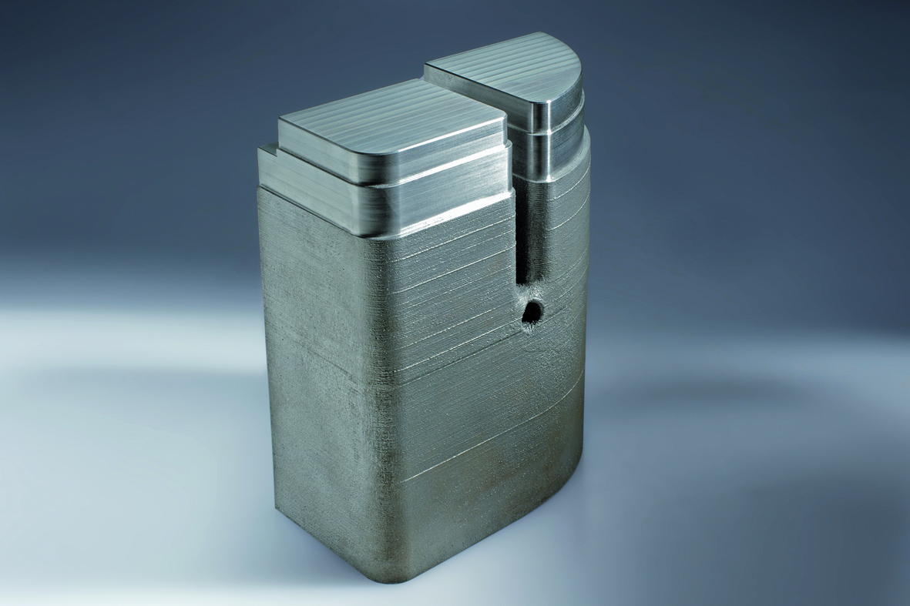 | Picture 1: Mold insert, made using the combined method of Selective Laser Melting and casting. Picture Source: Fraunhofer ILT, Aachen, Germany.

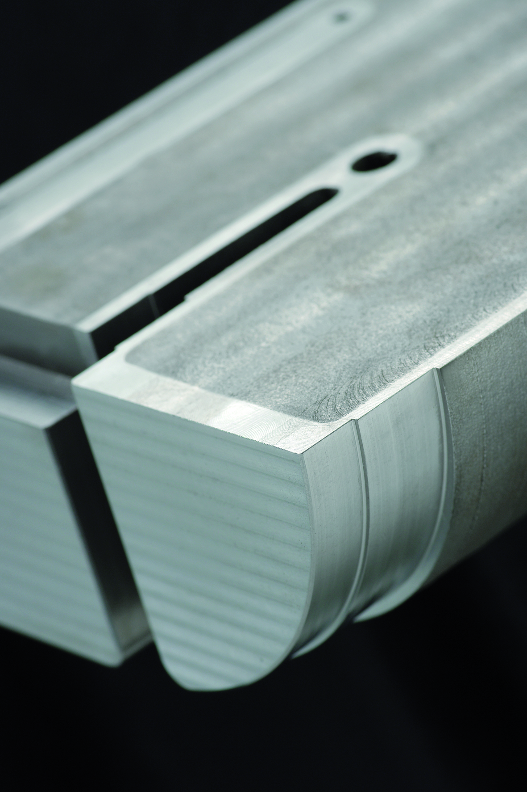 | Picture 2: Tool cavity of tool steel, made with SLM and filled with grey cast iron. Picture Source: Fraunhofer ILT, Aachen, Germany.

The Fraunhofer-Gesellschaft is the largest organization for applied research in Europe. Its research activities are conducted by 67 Fraunhofer Institutes at numerous locations throughout Germany. The Fraunhofer-Gesellschaft employs a staff of more than 23,000, who work with an annual research budget totaling 2 billion euros. Of this sum, 1.7 billion euros is generated through contract research. More than 70 percent of the Fraunhofer-Gesellschaft’s contract research revenue is derived from contracts with industry and from publicly financed research projects. Affiliated research centers and representative offices around the world provide contact with regions of greatest importance to present and future scientific progress and economic development.

Contact
Dr. Wilhelm Meiners | Head of the Rapid Manufacturing Group | Phone +49 241 8906-301 | wilhelm.meiners@ilt.fraunhofer.de
Dr. Konrad Wissenbach | Head of the Competence Area Additive Manufacturing and Functional Layers | Phone +49 241 8906-147 konrad.wissenbach@ilt.fraunhofer.de | Fraunhofer Institute for Laser Technology ILT, Aachen, Germany | www.ilt.fraunhofer.de
Dieses Feld, sowie die Tabelle auf der letzten Seite nicht löschen!

